

IN654 Business Systems Development

CW1 Project Output

By

Student 20140842

Bucks Student ID: 21402984

BSc (Hons) Software Engineering

**Buckinghamshire New University**

Table of Contents

System Design Artefacts 3

Data Flow Diagram 3

Use Case Diagram 4

Sequence Diagram 5

Entity Relationship Diagram 6

Data Dictionary 7

Customer Order Table 7

Customer Table 7

Category Table 7

Product Table 7

Ordered Product Table 7

SQL Scripts Test Data Population 8

Test Plan 9

UI Design 17

Index page 17

Category page 18

Cart page 19

Checkout Page 20

Confirmation Page 21

# System Design Artefacts

## Data Flow Diagram

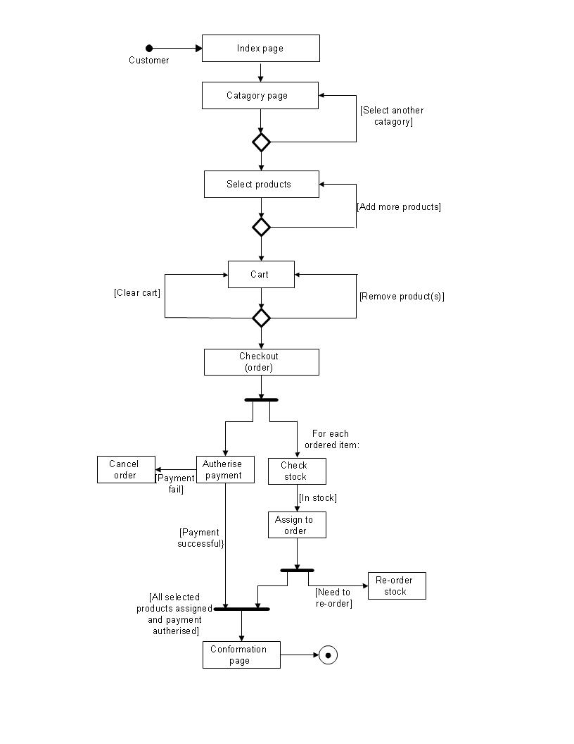

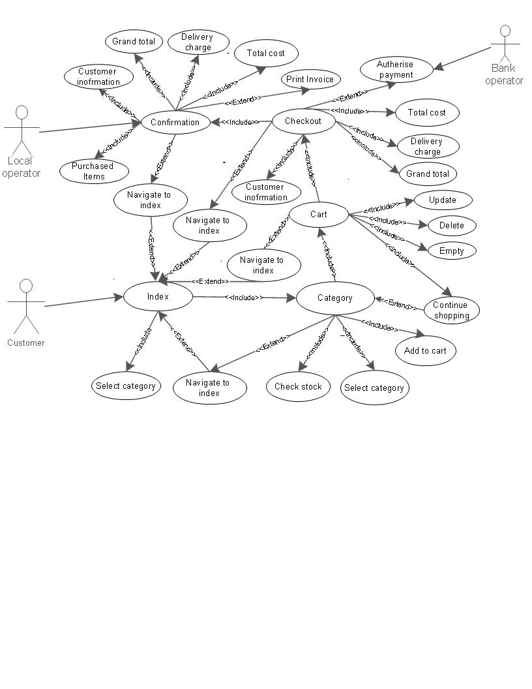Use Case Diagram

## Sequence.jpegSequence Diagram

# Entity Relationship Diagram

The ERD (Entity Relationship diagram) shown above, has been created using My SQL Workbench. This ERD outlines the five tables required for the project to store customer details, customer orders, the categories needed and the products of each category. Using two foreign keys, combined from the customer order table and the product table, this automatically generates a new table called ‘Ordered Product’. This catalogues the product(s) the customer has purchased and stores them in this new table.   
 This ERD is broken down into 3NF (3 Normalised Form) which allocates the appropriate items in each table, making the ERD simple to understand and navigate. Once these tables have been completed and linked using one-to-many relationships, this ERD can then be linked to the project so that these tables can hold data once the project is running.

## Data Dictionary

### Customer Order Table

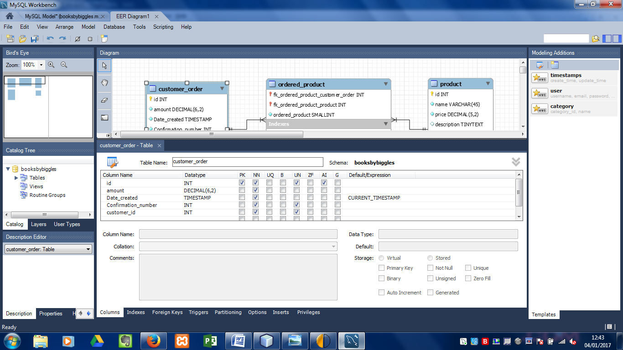

### Customer Table

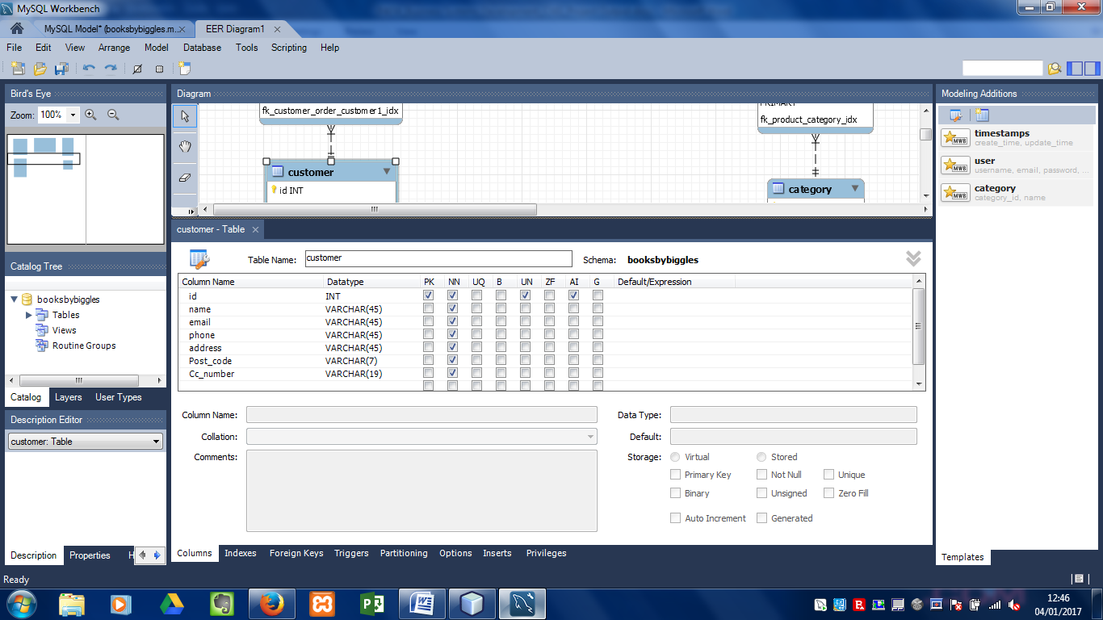

### Category Table

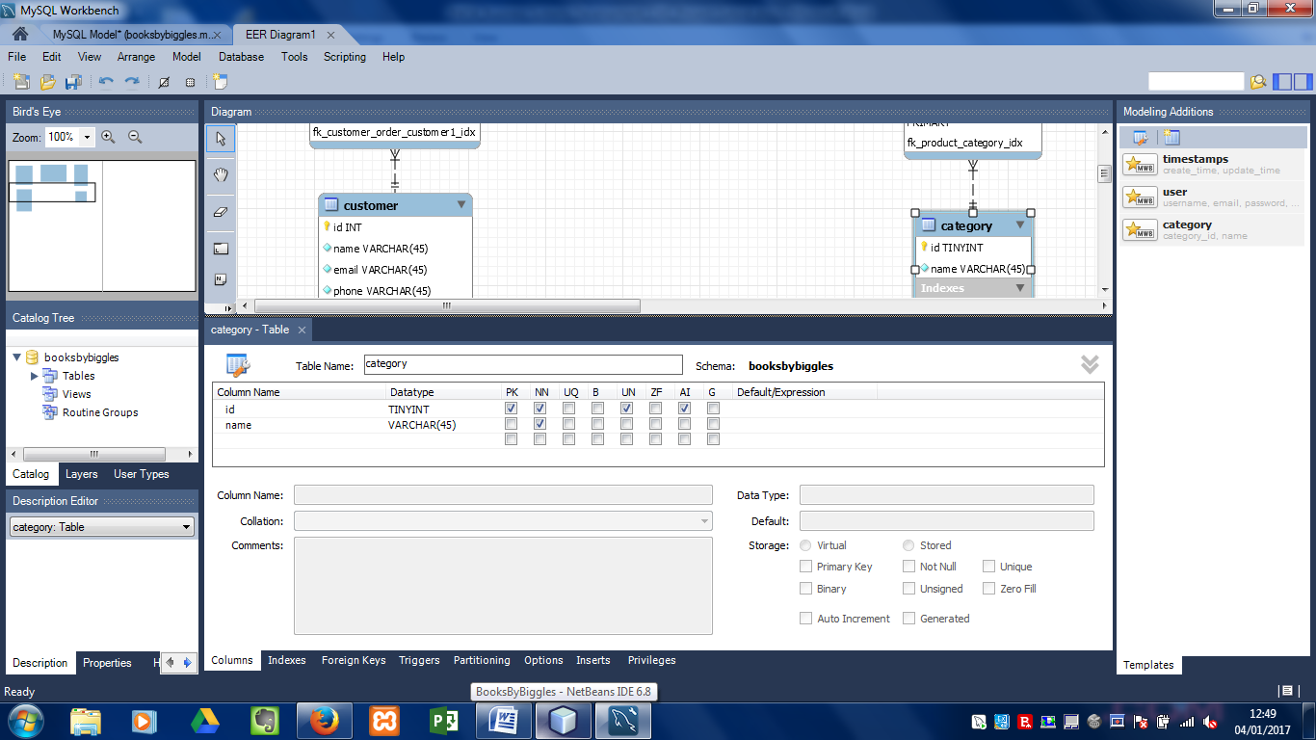

### Product Table

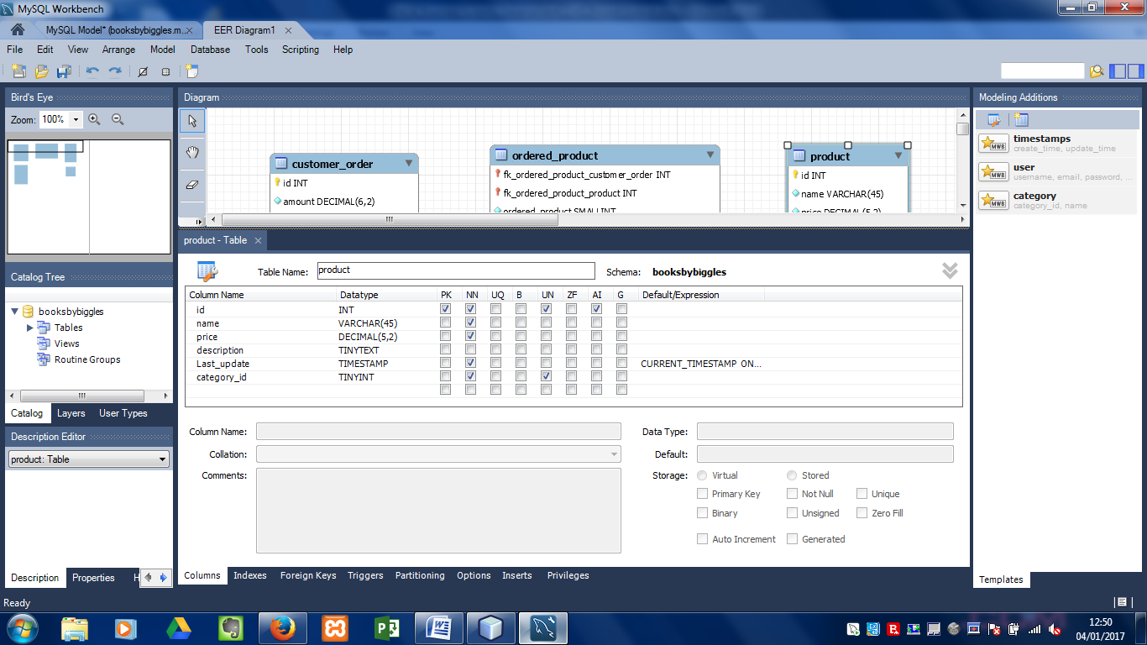

### Ordered Product Table

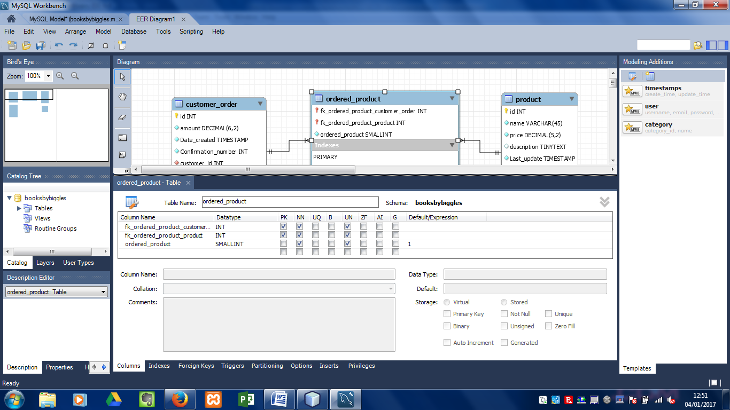

## SQL Scripts Test Data Population

INSERT INTO `category` (`name`) VALUES ('Education'),('Fiction'),('Politics'),('Science'),('Culture'), ('Language');

INSERT INTO `product` (`name`, price, description, category_id) VALUES ('GCSE English', 5.00 'GCSE English revision guide', 1);

INSERT INTO `product` (`name`, price, description, category_id) VALUES ('GCSE Science', 5.00, 'GCSE Science revision guide', 1);

INSERT INTO `product` (`name`, price, description, category_id) VALUES ('Game of Thrones', 7.50, 'A game of thrones by G.RR. martin', 2);

INSERT INTO `product` (`name`, price, description, category_id) VALUES ('LOTR', 7.50, 'The Fellowship of the Ring', 2);

INSERT INTO `product` (`name`, price, description, category_id) VALUES ('Change we can believe in', 14.29, 'Foreword by Barrack Obama', 3);

INSERT INTO `product` (`name`, price, description, category_id) VALUES ('Crippled America', 14.29, 'Donald J Trump', 3);

INSERT INTO `product` (`name`, price, description, category_id) VALUES ('A brief history of time', 10.50, 'Stephen hawking', 4);

INSERT INTO `product` (`name`, price, description, category_id) VALUES ('Black holes and baby universes', 11.50, 'Stephen Hawking', 4);

INSERT INTO `product` (`name`, price, description, category_id) VALUES ('Cultural literacy', 5.89, 'E.D. Hirsch JR.', 5);

INSERT INTO `product` (`name`, price, description, category_id) VALUES ('Riding the waves of culture', 4.19, 'F. Trompenaars', 5);

INSERT INTO `product` (`name`, price, description, category_id) VALUES ('Easy learning – Complete french', 3.15, 'Collins French dictionary, 6);

INSERT INTO `product` (`name`, price, description, category_id) VALUES ('Italian verbs', 2.39, Collins', 6);

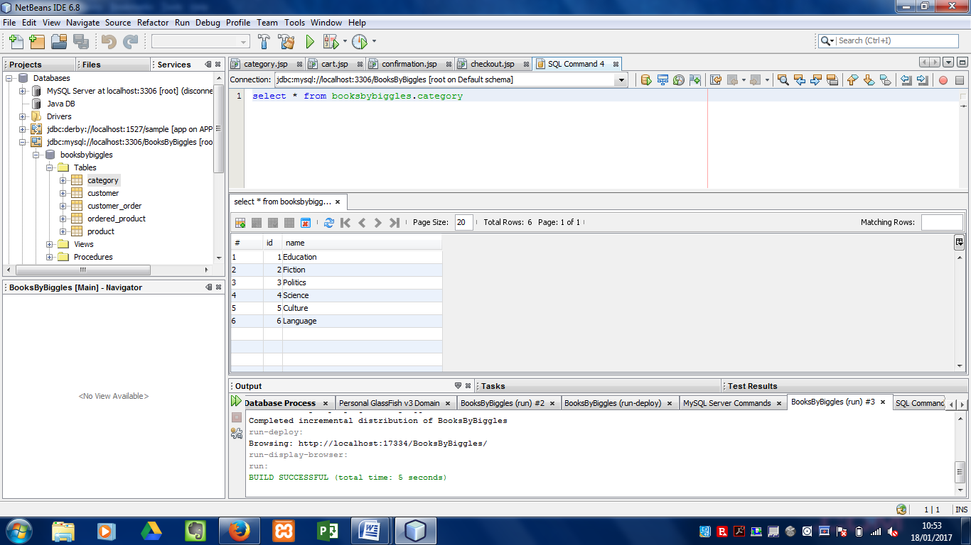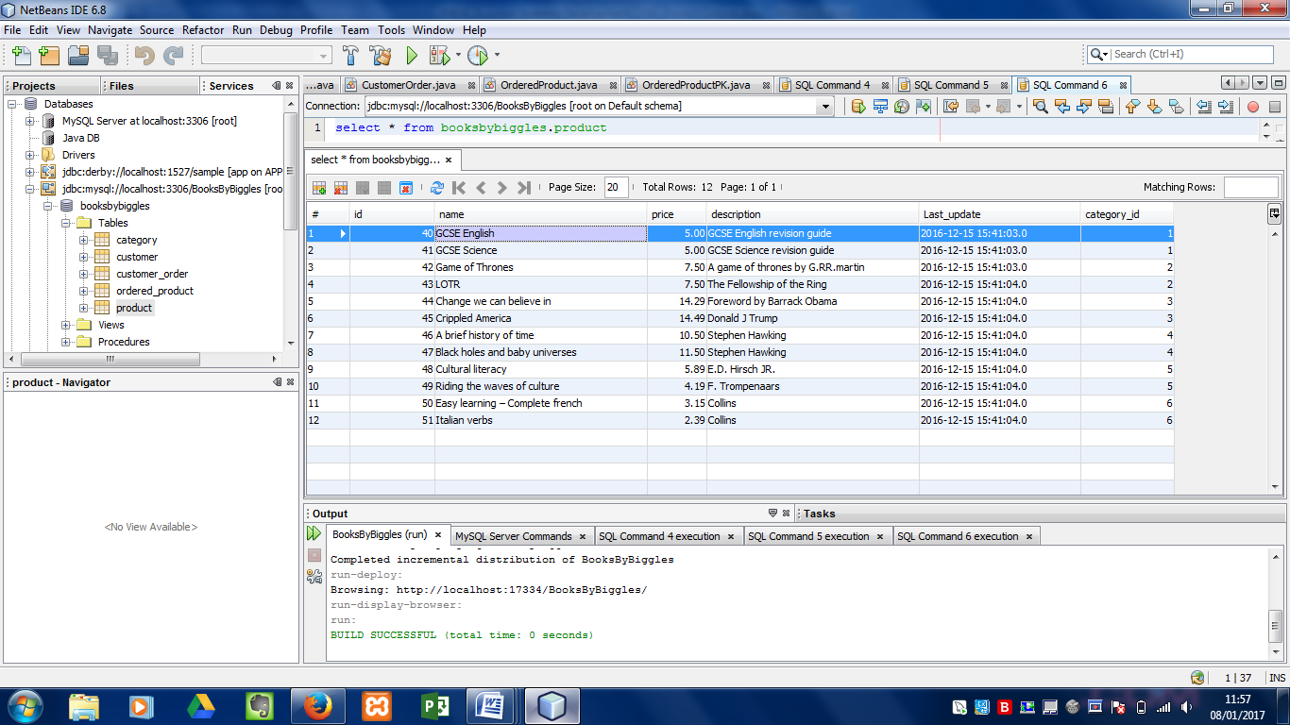

# Test Plan

|  |  |  |  |
| --- | --- | --- | --- |
| Test ID | Test | Pass/ Fail | Comments |
| 01 | Run Project (Index Page) | Pass | Project initializes and hosts to the web browser successfully. |
| 02 | Select ‘Education’ category | Pass | Customer is directed to the Education section of the ‘Categories’ page. |
| 03 | Select ‘Fiction’ category | Pass | Customer is directed to the Fiction section of the ‘Categories’ page. |
| 04 | Select ‘Politics’ category | Pass | Customer is directed to the Politics section of the ‘Categories’ page. |
| 05 | Select ‘Science’ category | Pass | Customer is directed to the Science section of the ‘Categories’ page. |
| 06 | Select ‘Culture’ category | Pass | Customer is directed to the Culture section of the ‘Categories’ page. |
| 07 | Select ‘Language’ category | Pass | Customer is directed to the Language section of the ‘Categories’ page. |
| 08 | All images for products display in the correct category box | Fail then Pass | Unidentifiable errors in the code do not allow product pictures to display. This was corrected by re-naming one line of code to generate the images. |
| 09 | Product name to display in failure of product picture | Pass | If product picture fails to display the product title will be displayed in place of the image. |
| 10 | All product titles display in the correct category box | Pass | Titles of all products in each category display when selected. |
| 11 | All product descriptions display in the correct category box | Pass | Product descriptions are displayed below the product title when selected. |
| 12 | All product prices display in the correct category box | Pass | Product prices are displayed when selected. |
| 13 | ‘Add to cart’ function | Pass | Item is added to cart upon selection of product. |
| 14 | Product table design | Pass | Product table displays the correct format, colours and layout from the CSS folder and the ‘Product.jsp’ page. |
| 15 | Category Highlight | Pass | Category is highlighted for the user to see which category they have selected. |
| 16 | Cart widget | Pass | Cart widget Is displayed in the header of each page. |
|  | View cart button | Pass | View cart button allows the customer to see their selected items in a table format under arranged headings. |
| 17 | Cart page | Pass | Cart page is layout in the designed and coded format, and displays the customers selected products. |
| 18 | Update cart widget | Pass | As each product is added to the cart, the cart updates and displays how many items the customer has selected. |
| 19 | Continue shopping widget | Pass | Allows customer to return to the ‘Category’ page to continue shopping. |
| 20 | Display product name (Cart) | Pass | All products selected are correctly named under the ‘Name’ heading. |
| 21 | Display product image (Cart) | Pass | The product image(s) are displayed correctly on the cart page under the heading ‘Product’. |
| 22 | Display product price (Cart) | Pass | The total price is displayed below the heading ‘Price’. Below the total price, the individual price per item is displayed. |
| 23 | Quantity number box | Pass | Customer is able to update the quantity of each item they wish to purchase. As this increases so does the product price. |
| 24 | Update quantity button | Pass | Customer must select this button to update the quantity of the selected product(s). |
| 25 | Quantity number box (0) | Pass | If the user inputs the figure ‘0’ into the quantity box and selects ‘Update’, this item will be removed from the list. |
| 26 | Display Sub-total | Pass | Sub total cost is clearly displayed above the product box. |
| 27 | Text displaying how many item you have in your cart | Pass | This text tells the customer how many items they have in their cart. |
| 28 | Clear cart button | Pass | This button allows the customer to clear their car if they are either not wanting to purchase anything or wish to select other items available. |
| 29 | Proceed to checkout button | Pass | Once the customer is satisfied with their purchase, they can then move onto the payment page by selecting the ‘Proceed to checkout’ button. |
| 30 | Checkout page | Pass | Checkout page is displays all the correct information about the customers purchases and displays input boxes for the customer to input customer details. |
| 31 | Checkout information text | Pass | Page displays instructions as to what the customer needs to do on this page. |
| 32 | Display delivery Information | Pass | Purchase information is displayed below the information text. This displays the cost of next day delivery. |
| 33 | Display checkout title | Pass | Checkout title is displayed below the cart widget. |
| 34 | Display active insert text field with title: ‘Name’ | Pass | Text box is displayed to allow the customer to enter their name. |
| 35 | Display active insert text field with title: ‘Email’ | Pass | Text box is displayed to allow the customer to enter their email address. |
| 36 | Display active insert text field with title: ‘Phone’ | Pass | Text box is displayed to allow the customer to enter their contact number. |
| 37 | Display active insert text field with title: ‘Address’ | Pass | Text box is displayed to allow the customer to enter their full address. |
| 38 | Display active insert text field with title: ‘UK’ | Pass | Drop down box is displayed to allow the customer to select their region number. |
| 39 | Display active insert text field with title: ‘Credit card number’ | Pass | Text box is displayed to allow the customer to enter their credit card details. |
| 40 | Checkout price column - sub total amount | Pass | The price box in the right hand column displays the sub total cost for the books wanting to be purchased by the customer. |
| 41 | Checkout price column - delivery charge | Pass | The price box in the right hand column displays the cost of delivery for the books purchased. |
| 42 | Checkout price column - total amount | Pass | The price box in the right hand column displays the total cost plus delivery fee for the books purchased. |
| 43 | Submit purchase button | Pass | Button allowing the customer to submit their details and complete a purchase order. This button then takes the user to the ‘Confirmation’ page where the customer can view their order. |
| 44 | Confirmation Page | Pass | Confirmation page displays correct layout and CSS. Displays customers purchase details to show the order has been approved. |
| 45 | Confirmation Text | Pass | This displays at the top of the body of the page and displays a message to the customer that they have completed their purchase. |
| 46 | Confirmation price column - sub total amount | Pass | The price box in the left hand column displays the sub total cost for the books purchased by the customer. |
| 47 | Confirmation price column - delivery charge | Pass | The price box in the left hand column displays the delivery cost for the books purchased. |
| 48 | Checkout price column - total amount | Pass | The price box in the left hand column displays the total cost plus delivery fee for the books purchased. |
| 49 | Display ‘Name’ in the ‘Details’ table | Pass | Customer name displays in the details table for the customer to view confirmation details. |
| 50 | Display ‘Email’ in the ‘Details’ table | Pass | Customer’s email address displays in the details table for the customer to view confirmation details. |
| 51 | Display ‘Phone’ in the ‘Details’ table | Pass | Customer’s phone number displays in the details table for the customer to view confirmation details. |
| 52 | Display ‘Address’ in the ‘Details’ table | Pass | Customer’s delivery address displays in the details table for the customer to view confirmation details. |
| 53 | Display ‘cityRegion’ in the ‘Details’ table | Pass | Customer’s post code is displayed to allow the customer to view confirmation details. |
| 54 | Display ‘Credit card number’ in the ‘Details’ table | Pass | Customer’s card details are displayed to allow the customer to view confirmation details. |
| 55 | Home button | Pass | Customer can choose to travel to the ‘Index’ page at any point by selecting the ‘Books By Biggles’ logo |
| 56 | Cart widget (All pages) | Pass | Customer can view their cart at any point during their visit to the website, providing the cart is not empty. |
| 57 | Layout | Pass | Layout is consistent with page format throughout all pages in the project. |
| 58 | CSS | Pass | CSS is consistent and meets required standards. Matches the layout of each page. |
| 59 | Suitable database | Pass | Database holds all data related to this project, allowing information to be called when requested by the website. |
| 60 | Notations | Pass | All code is annotated to display what each piece of code does throughout the project. |

# UI Design

## Index page

Background Color: #aaa : Grey

Proceed to checkout (Only visible if cart is full)

biggles.jpg  
{height: 155px;  
width: 155px;  
float: left;  
margin-left: 30px}

margin-top: -20px;

Cart.gif:  
{width: 194px;  
margin: 20px 2px;   
font-size: small;  
float: right;  
line-height: 25px; background: #aaa}

logoBBB.png {float: left; margin: 20px 0 0 70px; font-family: 'American Typewriter', Courier, monospace; font-size: 50px; color: #333: Black}

Culture  
Category box:  
{height: 140px;  
width: 106px;  
background: #ccc: Grey }

Science  
Category box:  
{height: 140px;  
width: 106px;  
background: #ccc: Grey }

Politics  
Category box:  
{height: 140px;  
width: 106px;  
background: #ccc: Grey }

Fiction  
Category box:  
{height: 140px;  
width: 106px;  
background: #ccc: Grey }

Education Category box:  
{height: 140px;  
width: 106px;  
background: #ccc: Grey}

Index Right Column: {height: 400px; width: 500px; float: left; background: #eee: Grey}

Footer: {height: 60px; width: 900px; clear: left; background: #aaa: Grey}  
© BooksByBiggles

(Insert welcome text here)  
Index left column:

{height: 300px;  
width: 300px;  
float: left;  
background: #ccc: Grey}

Language  
Category box:  
{height: 140px;  
width: 106px;  
background: #ccc: Grey }

## Category page

Footer: {height: 60px; width: 900px; clear: left; background: #aaa: Grey}  
© BooksByBiggles

Add Button

Price (£)

Add Button

Price (£)

Product Title:   
{line-height: 25px;  
 font-size: x-large}

Product Picture 2

Product Picture 1

Product Title:   
{line-height: 25px;  
 font-size: x-large}

#productTable { width: 600px }  
#productTable tr { height: 150px }  
#productTable td { width: 150px }  
#productTable {float: right}  
Table background-color: {#d3ede8: lightblue}

categoryRightColumn: {margin-top: 140px; width: 100px; float: right;  
 Main background: #eee: Grey}

categoryLeftColumn:  
{width: 100px;  
float: left;  
margin-top: 200px;  
margin-left: -600px;  
 padding-left: 5px;  
background: #ccc: Grey }

Cart.gif:  
{width: 194px;  
margin: 20px 2px;   
font-size: small;  
float: right;  
line-height: 25px; background: #aaa}

biggles.jpg  
{height: 155px;  
width: 155px;  
float: left;  
margin-left: 30px}

margin-top: -20px;

Proceed to checkout (Only visible if cart is full)

Background Color: #aaa : Grey

logoBBB.png {float: left; margin: 20px 0 0 70px; font-family: 'American Typewriter', Courier, monospace; font-size: 50px; color: #333}

Category Box Title: {margin: -34px 180px 0 0;  
font-size: x-large;  
float: left;  
background-color: #f5eabe: yellow;  
padding: 5px}

Education Button  
{margin: 10px 10px;  
padding: 12px;  
display: block;  
background-color: #d3ede8: lightblue}

Fiction Button

Politics Button

Science Button

Culture Button

Language Button

## Cart page

Footer: {height: 60px; width: 900px; clear: left; background: #aaa: Grey}  
© BooksByBiggles

Action Bar: {margin: 30px; width: 750px; text-align: center  
Main background: #eee: Grey }

cartTable: { width: 750px }  
carttable td: {width: 145px; height: 90px; Table background-color: {#d3ede8: lightblue}

Subtotal: { margin: 40px 0 20px 430px }

Update Cart

Product Name Price Quantity

1

Price (£)

Product Title:   
line-height: 25px;  
 font-size: x-large;

Product   
Picture



Background Color: #aaa : Grey

Proceed To Checkout  
color: #f5eabe: yellow

Continue Shopping  
color: #f5eabe: yellow

Clear Cart  
color: #f5eabe: yellow

## Checkout Page

Footer: {height: 60px; width: 900px; clear: left; background: #aaa: Grey}  
© BooksByBiggles

Submit purchase Button

checkoutTable {width: 360px; background-color: #f5eabe: Yellow; float: left; height: 280px}

(Insert credit card number)

(Insert post code)

(Insert Address)

(Insert name)

(Insert email)

Credit card:

Post Code

Address

Email

Name:

Instruction box for customer payment details

**Checkout**

Subtotal:  
Delivery charge:  
Total:  
{padding: 10px;  
margin: 10px 0;  
height: 128px;  
background-color: #c3e3e0: Light blue}



Background Color: #aaa : Grey

Delivery Information:  
{width: 300px;  
padding-left: 30px;  
float: left;

## Confirmation Page

Delivery Address Table   
{width: 70%;  
margin-left: 15%;  
text-align: left;  
height: 200px;  
background-color: #f5eabe: Yellow}



Subtotal:  
Delivery charge:  
Total:

orderSummaryTable   
{width: 100%;  
text-align: left;  
height: 200p;  
background-color: #c3e3e0: Light blue }

Background Color: #aaa : Grey

Footer: {height: 60px; width: 900px; clear: left; background: #aaa: Grey}  
© BooksByBiggles

summaryColumn {margin-top: 15px; width: 50%; float: left}

Confirmation Text {margin: 0 20px 20px; padding: 10px; background-color: #f5eabe: light blue; float: left width:540px}

